Chapter 2 Exercise 4

FORMAT: [year, “men” count, “women” count, “people” count]

1945 2 2 10 1946 12 7 49 1947 7 2 12 1948 4 1 22 1949 2 1 15 1950 6 2 15
1951 8 2 9 1953 3 0 17 1954 2 0 15 1955 4 0 26 1956 2 2 30 1957 5 2 11
1958 2 1 19 1959 4 1 11 1960 2 0 10 1961 6 0 10 1962 6 2 10 1963 0 0 3
1963 8 5 12 1964 3 1 3 1965 7 0 16 1965 11 3 14 1966 12 1 35 1967 11 1 25
1968 4 0 17 1969 5 2 6 1970 2 0 23 1971 1 0 31 1972 1 0 7 1973 0 0 9
1974 0 0 19 1975 0 0 13 1976 3 1 18 1977 2 1 17 1978 0 1 26 1979 0 1 15
1980 1 2 11 1981 1 1 11 1982 1 1 17 1983 3 7 19 1984 3 5 23 1985 1 1 12
1986 2 2 14 1987 1 0 24 1988 1 0 16 1989 2 3 13 1990 3 2 9 1991 2 2 13
1991 7 7 13 1992 4 4 26 1993 1 2 45 1994 1 1 63 1995 1 3 73 1996 2 3 40
1997 1 2 30 1998 2 2 22 1999 2 3 22 2000 5 6 41 2001 3 3 14 2001 1 2 12
2002 3 5 14 2003 6 4 33 2004 6 8 21 2005 8 11 18 2006 7 7 22

Total
men: 228
women: 141
people: 1291

Over time, there doesn’t seem to be any sort of trend for any of the words. All three sort of fluctuate erratically with no real consistent behavior. One thing that can be said is that all three words experienced a slight increase in general usage over the period of 60 years.

Chapter 2 Exercise 5

Output for 7 different nouns, many of them have each other in a meronym/holonym relationship.

TREE.N.01
Part Meronyms: ['burl.n.02', 'crown.n.07', 'limb.n.02', 'stump.n.01', 'trunk.n.01']
Substance Meronyms: ['heartwood.n.01', 'sapwood.n.01']
Member Meronyms: []
Part Holonyms: []
Substance Holonyms: []
Member Holonyms: ['forest.n.01']

HEARTWOOD.N.01
Part Meronyms: []
Substance Meronyms: []
Member Meronyms: []
Part Holonyms: []
Substance Holonyms: ['tree.n.01']
Member Holonyms: []

FOREST.N.01
Part Meronyms: []
Substance Meronyms: []
Member Meronyms: ['tree.n.01', 'underbrush.n.01']
Part Holonyms: []
Substance Holonyms: []
Member Holonyms: []

CAR.N.01
Part Meronyms: ['accelerator.n.01', 'air_bag.n.01', 'auto_accessory.n.01', 'automobile_engine.n.01', 'automobile_horn.n.01', 'buffer.n.06', 'bumper.n.02', 'car_door.n.01', 'car_mirror.n.01', 'car_seat.n.01', 'car_window.n.01', 'fender.n.01', 'first_gear.n.01', 'floorboard.n.02', 'gasoline_engine.n.01', 'glove_compartment.n.01', 'grille.n.02', 'high_gear.n.01', 'hood.n.09', 'luggage_compartment.n.01', 'rear_window.n.01', 'reverse.n.02', 'roof.n.02', 'running_board.n.01', 'stabilizer_bar.n.01', 'sunroof.n.01', 'tail_fin.n.02', 'third_gear.n.01', 'window.n.02']
Substance Meronyms: []
Member Meronyms: []
Part Holonyms: []
Substance Holonyms: []
Member Holonyms: []

HOOD.N.09
Part Meronyms: ['hood_ornament.n.01']
Substance Meronyms: []
Member Meronyms: []
Part Holonyms: ['airplane.n.01', 'car.n.01']
Substance Holonyms: []
Member Holonyms: []

BASKETBALL.N.01
Part Meronyms: ['basketball_play.n.01', 'basketball_shot.n.01', 'half.n.02', 'rebound.n.03', 'tip-off.n.02']
Substance Meronyms: []
Member Meronyms: []
Part Holonyms: []
Substance Holonyms: []
Member Holonyms: []

REBOUND.N.03
Part Meronyms: []
Substance Meronyms: []
Member Meronyms: []
Part Holonyms: ['basketball.n.01']
Substance Holonyms: []
Member Holonyms: []

Chapter 2 Exercise 7

Output shows the use of “however” in 4 differnet usages in various Brown texts. Most often used as a contradictory transition.

both governments '' . Merger proposed However , the jury said it believes `` these t
artment source told The Constitution , however , that Vandiver has not been consulted
ing to the election was not so quiet , however . It was marked by controversy , anony
aos . ( Some SEATO nations disagreed , however . ) There was the further complication

Chapter 2 Exercise 9

“White”
In Edgeworth Parents, it is used to describe a Pigeon throughout.
In Moby Dick, it is used to describe people, in a racial context.

Chapter 2 Exercise 12

The CMU Dictionary has 123,455 distinct words. Around 7.5% of them have more than one pronunciation.

Chapter 2 Exercise 17 & 18
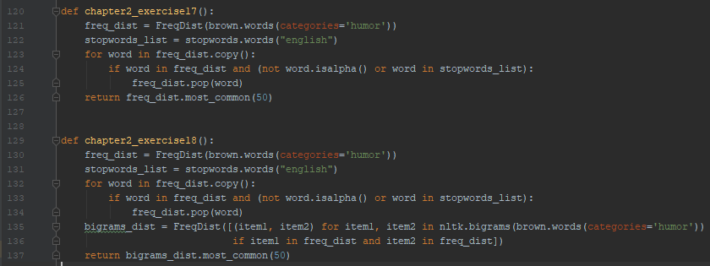
Chapter 2 Exercise 27

Average Polysemy of Nouns = 1.28
AP of Verbs = 2.19
AP of Adjectives = 1.25
AP of Adverbs = 1.41

Chapter 3 Exercise 20
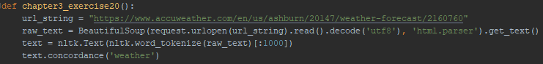
Chapter 3 Exercise 22

RegEx: “/\b\w+/

Chapter 6 Exercise 4

30 most informative features

- Insulting
- Avoids
- Gripping
- Sucks
- Astounding
- Ludicrous
- Hudson
- 3000
- Regard
- Slip
- Outstanding
- Excruciatingly
- Incoherent
- Sans
- Fascination
- Elliot
- Thematic
- Hatred
- Hers
- Seamless
- Illogical
- Fairness
- Feeble
- Anger
- Stupidity
- Finest
- Addresses
- Dread
- Seagal
- Furniture

